Test IT

Internet works

 it is indirectly connected to the internet through an Internet Service Provider (ISP) and is identified by an IP address, which is a string of numbers. Just like you have an address for your home that uniquely identifies your home, an IP address acts as the shipping address of your device. The IP address is provided by your ISP, and you can see what [IP](https://www.javatpoint.com/ip-full-form)

address your ISP has given to your system.

A server is a large computer that stores websites. It also has an IP address. A place where a large number of servers are stored is called a data center. The server accepts requests send by the client through a browser over a network (internet) and responds accordingly.

 each IP address has been assigned a domain name. For example, youtube.com, facebook.com, paypal.com are used to represent the IP addresses. Domain names are created as it is difficult for a person to remember a long string of numbers. However, internet does not understand the domain name, it understands the IP address, so when you enter the domain name in the browser search bar, the internet has to get the IP addresses of this domain name from a huge phone book, which is known as [DNS](https://www.javatpoint.com/dns-full-form)

**Let see how internet works:**

When you turn on your computer and type a domain name in the browser search bar, your browser sends a request to the DNS server to get the corresponding IP address. After getting the IP address, the browser forwards the request to the respective server.

Once the server gets the request to provide information about a particular website, the data starts flowing. The data is transferred through the optical fiber cables in digital format or in the form of light pulses

The optical fiber is connected to a router, which converts the light signals into electrical signals. These electrical signals are transmitted to your laptop using an Ethernet cable. Thus, you receive the desired information through the internet, which is actually a cable that connects you with the server.

Furthermore, if you are using wireless internet using wifi or mobile data, the signals from the optical cable are first sent to a cell tower and from where it reaches to your cell phone in the form of electromagnetic waves.

**Reason for internet speed:**

The reason for this speed is that the data is sent in the binary form (0, 1), and these zeros and ones are divided into small pieces called packets, which can be sent at high speed.

**Intranet:** The intranet is a private network that belongs to a particular organization. It is designed for the exclusive use of an organization and its associates, such as employees, customers, and other authorized people. It offers a secure platform to convey information and share data with authorized users.

**Some of the benefits of the intranet are:**

* It is cheap and easy to implement and run, and is more safe than the internet and [extranet](https://www.javatpoint.com/extranet).
* It streamlines communication that enables the company to share its data, information, and other resources among employees without any delay. The entire staff can receive company's announcements, ask questions, and access internal documents.
* It provides a secure space to store and develop applications to support business operations.
* It improves the efficiency of the company by speeding up workflow and reducing errors. Thus, it helps achieve targets by completing the tasks on time.
* Thus, it helps maintain the credibility of the company
* Information is shared in real-time, or updates are reflected immediately to all the authorized users.
* Modern intranets also offer a mobile app that allows employees to stay connected on the go.
* It aids in project management and tracking workflow and teams' progress.
* It can work with mobile devices, which means it can provide information that exists on intranet directly to mobile devices of employees such as phones, tablets, etc.
* It can also be used to motivate employees, facilitate employee recognition, and to reward them for performing beyond expectations.

Disadvantages of Intranet:

* It may be costly to set up an Intranet due to hidden costs and complexity.
* If the firewall does not work properly or not installed, it can be hacked by someone
* High-security passwords are required, which cannot be guessed by outside users
* There is always a fear of losing control over the intranet
* Sometimes document duplication may happen which can cause confusion among employees
* You have to give access to multiple users, so you may find it hard to control this network.

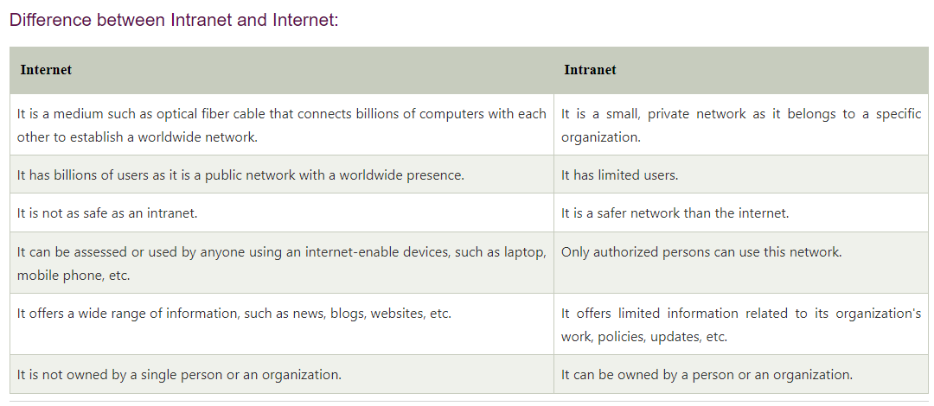

Key Milestones in Evolution of Internet

1950’s

ARPA (Advanced Research Project Agency)

1971

Telnet and FTP are available

▪ Telnet- you can start a remote session on a different computer sitting on your own computer

▪ FTP – you can transfer a file or group of files between two machines.

1991

◦ Archie and Gopher released

▪ Archie

• was developed as an FTP search engine

• It returns list of FTP sites, where you could possibly get that resource.

▪ Gopher

• more intelligent version of Archie

• shows document in category and sub-category view

• covered both FTP sites and non FTP sites also

• 1992

◦ Internet links more than 17,000 networks in 33 countries; 3 million hosts

• 1993

◦ World wide web application is launched

2021

◦ 584 (ISPs) in India as of 30 September, 2021.

◦ Jio, Airtel, Vi, BSNL as major ISPs

Web Server

The term web server can refer to hardware or software, or both of them working together

**1 On the hardware side**

web server is a computer that stores web server software and a website's component files (for example, HTML documents, images, CSS stylesheets, and JavaScript files) →

a web server connects to the Internet and supports physical data interchange with other devices connected to the web.

## What is a Proxy Server?

A proxy server acts as a gateway between you and the internet. It’s an intermediary server separating end users from the websites they browse. Proxy servers provide varying levels of functionality, security, and privacy depending on your use case, needs, or company policy.

If you’re using a proxy server, internet traffic flows through the proxy server on its way to the address you requested. The request then comes back through that same proxy server (there are exceptions to this rule), and then the proxy server forwards the data received from the website to you.

## Proxy Server Risks

You do need to be cautious when you choose a proxy server: a few common risks can negate any of the potential benefits:

* **Free proxy server risks**
* **Browsing history log**
* **No encryption**
  + .

## Types of Proxy Servers

**Transparent Proxy**

**Anonymous Proxy**

**Distorting proxy**

**High Anonymity proxy**